high-performance thermoplastic polymers

Polyetheretherketone (PEEK)
PEEK (polyetheretherketone) is a semicrystalline, high-temperature (up to 500° F) engineering thermoplastic that is excellent for applications where thermal, chemical, and combustion properties (UL flammability rating of V-0) are critical to performance. At the same time, PEEK emits little smoke or toxic gas when exposed to flame. This material is tough, strong, and rigid and has superior creep resistance. It also resists radiation and a wide range of solvents. With its resistance to hydrolysis, PEEK can withstand boiling water and superheated steam used with autoclave and sterilization equipment at temperatures higher than 482° F. PEEK resins are available in unreinforced, 30% glass-fiber reinforced, 30% carbon-fiber reinforced, and HPV-reinforced grades. Typical applications include the automotive, marine, nuclear, oil-well, electronics, medical and aerospace industries.

Key Properties
- Continuous service temperature of 500º F
- Low smoke and toxic-gas emissions
- Very low moisture absorption
- Excellent fatigue, stress-crack, hydrolysis and chemical resistance
- Superior creep resistance

Standard Shapes and Forms
Sheet: .250” – 4” thick
Rod: .250” – 6” diameter
Tubular Bar: 2.00” - 10.125” OD x 1.25” - 8.25” ID
The range of sizes and shapes are grade specific, please contact us for more information.
Grades

PEEK, Unfilled
Unfilled PEEK is an unreinforced general-purpose grade that offers steam and wear resistance. It provides the greatest elongation and toughness of all PEEK grades. It is ideal for instrument components where aesthetics is a concern. It also is well suited for seal components where ductility and inertness are important.

PEEK, 30% Glass-Fiber Reinforced
The addition of glass fiber greatly reduces the expansion rate and increases the flexural modulus of PEEK. This grade is especially good for structural applications that require greater strength, stiffness, or stability—especially at temperatures higher than 300º F.

PEEK, 30% Carbon-Fiber Reinforced
The addition of carbon fibers enhances the compressive strength and stiffness of PEEK, while dramatically lowering its expansion rate. It offers optimum wear-resistance and load-carrying capability in a PEEK-based product. This grade provides greater thermal conductivity than unreinforced PEEK, allowing for increased heat dissipation from bearing surfaces. The result is improved bearing life and capability.

PEEK, Bearing grade
Carbon fiber reinforced with graphite and PTFE lubricants, bearing grade PEEK offers the lowest coefficient of friction and the best machinability of all PEEK grades. An excellent combination of low friction, low wear, high LPV, low mating part wear and easy machining, make it ideal for aggressive service bearings.

Polyaryletherketon (PAEK)
PAEK (polyaryletherketone) is a family of high-performance polyketones tailored to fill cost and performance gaps between PEEK and other high-performance polymers. For example, ductility and toughness can be significantly improved versus comparable grades of PEEK, delivering 20% higher tensile elongation at yield and doubled tensile elongation at break values.
Depending on the grade, AvaSpire® PAEK outperforms comparable grades of PEEK.
- Higher stiffness from 150 °C to 190 °C (302 °F to 374 °F)
- Improved ductility and toughness
- Equal or better chemical resistance
- UL-94 V0 rating at 0.8 mm
- Comparable strength and stiffness at up to 30% lower cost
- Excellent aesthetics and colorability

Choose the Performance You Need
AvaSpire® PAEK is available in:
- Neat grades (lubricated, non-lubricated)
- Glass fiber and carbon fiber reinforced grades (structural grades)
- Wear resistant SL grades (lubricated, non-lubricated, load bearing)

Glass fiber and carbon fiber reinforced KetaSpire® PEEK grades deliver the greater mechanical robustness required for structural applications.
Discover more at AvaSpire.com
Comparison of neat grades
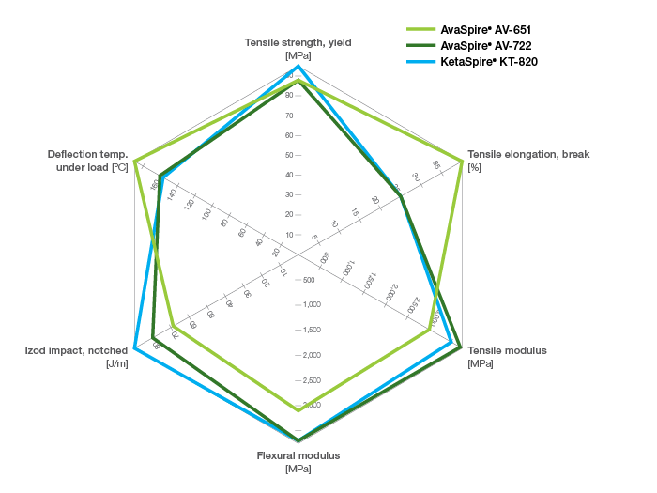

Comparison of glass fiber reinforced grades
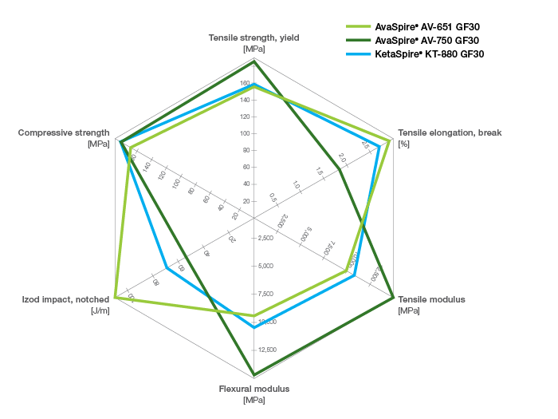
Comparison of carbon fiber reinforced grades
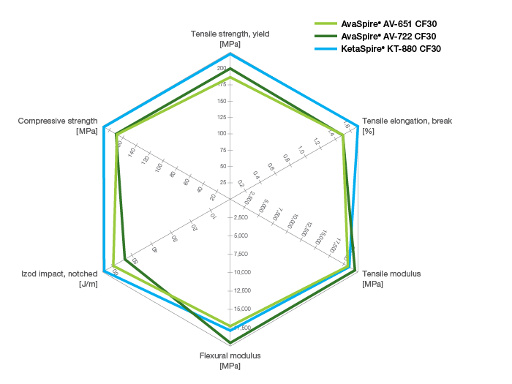

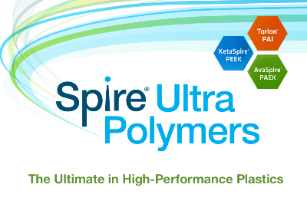
Spire® Ultra Polymers
The Ultimate in High-Performance Plastics
An unparalleled offering that gives engineers more flexibility to optimize their designs to reduce weight, lower cost, eliminate corrosion and ultimately outperform the competition in demanding industries, including Aerospace, Automotive, Oil & Gas, Healthcare, Semicon, Industrial Coatings, and Wire & Cable.
Polyetherimide (PEI)
n amorphous, amber-to-transparent thermoplastic with characteristics similar to the related plastic PEEK. Relative to PEEK, PEI is cheaper, but is lower in impact strength and usable temperature.^{[1]}.
Because of its adhesive properties and chemical stability it became a popular bed material for FDM 3D printers

Structure
The molecular formula of the repeating unit of PEI is C₃₇H₂₄O₆N₂ and the molecular weight is 592.61 g/mol.^{[2]}

Properties
The glass transition temperature of PEI is 217 °C. Its amorphous density at 25 °C is 1.27 g/cm³. It is prone to stress cracking in chlorinated solvents. Polyetherimide is able to resist high temperatures with stable electrical properties over a wide range of frequencies. This high strength material offers excellent chemical resistance and ductile properties suitable for various applications, even those including steam exposure.^{[3]}

Ultem
Ultem is a family of PEI products manufactured by SABIC as a result of acquiring the General Electric Plastics Division in 2007, developed by Joseph G. Wirth in the early 1980s. Ultem resins are used in medical and chemical instrumentation due to their heat resistance, solvent resistance and flame resistance. Ultem 1000 (standard, unfilled polyetherimide) has a high dielectric strength, inherent flame resistance, and extremely low smoke generation. Ultem has high mechanical properties and performs in continuous use to 340 °F (170 °C) and is easily machined and fabricated with excellent strength and rigidity.^{[4]} Ultem 1000 has typical thermal conductivity of 0.22 W/m·K (but some sources give 0.122 W/m·K). It has "Questionable usage on alkaline solutions."^{[5]}

References
  - Jump up ^ http://www.mcmaster.com/#ultem/=otzvqt Referenced Oct 7, 2013
  - Jump up ^ Scott, Chris. "polyetherimide information and properties". www.polymerprocessing.com. Retrieved 2018-04-30.
  - Jump up ^ "Injection Molding Material Selection Guide". www.abtecinc.com. Retrieved 2018-04-30.
  - Jump up ^ "Ultem PEI Plastic - Polyetherimide Sheets | Regal Plastics". www.regal-plastics.com. Retrieved 2018-04-30.
  - Jump up ^ https://www.asconumatics.eu/images/site/upload/_en/pdf1/00012gb.pdf

Polyphenylene sulfide (PPS)
What is PPS - Polyphenylene Sulfide?
Polyphenylene sulfide (PPS) is a semi crystalline, high temperature engineering thermoplastic. It is rigid and opaque polymer with a high melting point (280°C). It consists of para-phenylene units alternating with sulfide linkages. PPS offers an excellent balance of properties like:
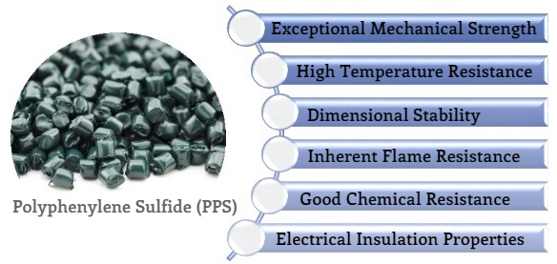
And, it can be easily processed as well as its toughness increases at high temperatures.
These assets make Polyphenylene sulfide a chosen alternative to metals & thermosets for use in automotive parts, appliances, electronics and several others applications.
Some of the key producers of PPS include:
» Toray Resin Company - TORELINA®, TORAYCA®
» RTP Company - RTP 1300 series
» Solvay - Ryton®, PrimoSpire®, Tribocomp®
» Celanese - FORTRON®, CoolPoly®, Celstran®
» Polyplastics - DURAFIDE®
» SABIC - LNP™ LUBRICOMP™, LNP™ STAT-KON™, LNP™ THERMOCOMP™ and more
» Lehman & Voss - LUVOCOM®
» View >1600 Commercially Available PPS Grades & >80 Suppliers in Omnexus Plastics Database
This plastic database is available to all, free of charge. You can filter down your options by property (mechanical, electrical…), applications, conversion mode and many more dimensions.
What is PPS Made From?
The first commercial process for PPS was developed by Edmonds and Hill (US patent 3 354 129, Yr. 1967) while working at Philips Petroleum under the brand name Ryton.
Today, all commercial processes use improved versions of this method. PPS is produced by reaction of sodium sulphide and dichlorobenzene in a polar solvent such as N-methylpyrrolidone and at higher temperature [at about 250° C (480° F)].
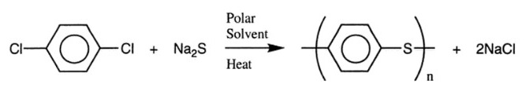
In the original process developed by Philips, the product obtained has a low molecular weight and can be used in this form for coating applications. To produce molding grades, PPS is cured (chain extended or crosslinked) around the melting point of the polymer in the presence of a small amount of air. This curing process results in:
- Increase in molecular weight
- Increased toughness
- Loss of solubility
- Decrease in melt flow
- Decrease in crystallinity
- A darkening in color (a brownish color in contrast to this linear PPS grades are off-white)
Over the period of time, modification to the process have been reported to eliminate curing stage & develop products with improved mechanical strength.
Regular PPS is an off-white, linear polymeric material of modest molecular weight and mechanical strength. When heated above its glass transition temperature (Tg ~85°C), it crystallizes rapidly. Main three types of PPS include:
Linear PPS
- The MW of this polymer is nearly double as compared to regular PPS.
- The increased molecular chain length results in high tenacity, elongation and impact strength
Cured PPS
- Obtained from heating of regular PPS in the presence of air (O₂)
- Curing results in molecular chain extension & formation of some molecular chain branches increases the MW and provides some thermoset-like characteristics
Branched PPS
- Has higher MW than regular PPS
- The backbone of the extended molecule has extended polymer chin branched from it
- Branched PPS has improved mechanical properties, tenacity and ductility
Key Properties of Polyphenylene Sulfide (PPS)
In the above section, we discussed about the general characteristics of Polyphenylene sulfide. It is also important to mention that there are several other properties of Polyphenylene sulfide that should be considered before employing it for a specific application. Let’s discuss all the properties of PPS in detail…
Crystal Structure and Physical Properties
PPS is a semi-crystalline polymer.
- The unit cell is orthorombic (a=0.867 nm, b=0.561 nm, c=1.026 nm)
- The heat of fusion for an ideal PPS crystal was calculated as 112 J/g
- Depending from thermal history, molecular weight and cross-linked status (linear or not) the degree of crystallinity ranges from 0.30 to 0.45%
- Amorphous and crosslinked PPS can be prepared by:
  - Heating the material above the melting temperature
  - Cooling it to around 30°C below the melting temperature, and
  - Holding it for several hours in the presence of air
Knowledge about the crystallization behavior of PPS is very important to understand the recommended processing parameters. The following table shows the phase transition temperatures of PPS. Ranges depend on mol. weight and curing status (linear or crosslinked).
Glass Transition Temperature (Tg) | 85 - 95 °C
Crystallization on Heating (Tc-h) | 120 - 140 °C
Cristallite Melting (Tm) | 275 - 285 °C
Recrystallization on cooling (T c-c) | 255 - 225 °C
Density | 1.35 g/cm³
Gamma Radiation Resistance | Good
UV Light Resistance | Good
HDT @0.46 Mpa (67 psi) | 140 - 160 °C
HDT @1.8 Mpa (264 psi) | 100 - 135 °C
Max Continuous Service Temperature | 200 - 220 °C
Thermal Insulation (Thermal Conductivity) | 0.29 - 0.32 W/m.K
Phase Transition Temperatures & Other Physical Properties of PPS
Dimensional Stability
PPS is an ideal material of choice to produce complex parts with very tight tolerances. The polymer exhibits an excellent dimensional stability even when used under high temperature and high humidity conditions.
Coefficient of Linear Thermal Expansion | 3 - 5 x 10⁻⁵ /°C
Shrinkage | 0.6 - 1.4 %
Water Absorption 24 hours | 0.01 - 0.07 %
Electrical Properties
PPS has excellent electrical insulation properties. Both the high-volume resistivity and insulation resistance are retained after exposure to high-humidity environments. It has a less pronounced O₂ sensitivity and can be conveniently doped to get high conductivity.
Arc Resistance | 124 sec
Dielectric Constant | 3 - 3.3
Dielectric Strength | 11 - 24 kV/mm
Dissipation Factor | 4 - 30 x 10⁻⁴
Volume Resistivity | 15 - 16 x10¹⁵ Ohm.cm
Thermal Properties and Fire Resistance
PPS is a high-temperature specialty polymer. Most of the PPS compounds pass UL94V-0 standard without adding flame retardant. PPS can be resistance to 260°C for short time and used below 200°C for a long time.
Fire Resistance (LOI) | 43 - 47 %
Flammability UL94 | V0
Mechanical Properties
PPS has high strength, high rigidity and low degradation characteristics even in high temperature conditions. It also shows excellent fatigue endurance and creep resistance.
Elongation at Break | 1-4%
Elongation at Yield | 1-4%
Flexibility (Flexural Modulus) | 3.8-4.2 GPa
Hardness Rockwell M | 70-85
Hardness Shore D | 90-95
Stiffness (Flexural Modulus) | 3.8-4.2 GPa
Strength at Break (Tensile) | 50-80 MPa
Strength at Yield (Tensile) | 50-80 MPa
Toughness (Notched Izod Impact at Room Temperature) | 5 - 25 J/m
Young Modulus | 3.3 - 4 GPa
Click here to compare the mechanical properties of reinforced grades vs. unfilled neat polymer
Chemical Properties
PPS has good chemical resistance. If cured, it is unaffected by alcohols, ketones, chlorinated aliphatic compounds, esters, liquid ammonia etc. however, it tends to be affected by dilute HCl and nitric acids as well as conc. sulphuric acid. It is insensitive to moisture and has good weatherability.
Click here to see chemical properties of PPS in detail
PPS has however, a lower elongation to break, a higher cost and is rather brittle. Today, PPS is available in different forms and grades such as compounds, fibers, filaments, films and coatings.
How to Optimize PPS Properties?
Search PPS Grades Based on
Their Reinforcement Method

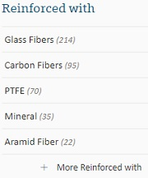

There is a great number of PPS compounds in the market. Due to the chemical robustness of the polymer, a great variety of fillers and reinforcing fibers and combinations of these can be applied.
PPS resin is generally reinforced with various reinforcing materials or blended with other thermoplastics in order to further improve its mechanical and thermal properties. PPS is more used when filled with glass fiber, carbon fiber, and PTFE.

Many grades are available including:
- Unfilled Natural
- 30% and 40% glass filled
- Glass mineral filled
- Conductive and Anti-Static Grades
- Internally lubricated bearing grades
However, on the market PPS-GF40 and PPS-GF MD 65 are established as standard compounds. These two have the overwhelming market share.
As you can see, the mechanical properties of reinforced grades differ significantly from the unfilled neat polymer. The typical property values for reinforced and filled grades fall in the range as shown in the table below.
Property (Unit) | Test Method | Unfilled | Glass Reinforced | Glass-Mineral Filled*
Filler Content (%) |  | - | 40 | 65
Density (kg/l) | ISO 1183 | 1.35 | 1.66 | 1.90 - 2.05
Tensile Strength (Mpa) | ISO 527 | 65-85 | 190 | 110-130
Elongation at Break (%) | ISO 527 | 6-8 | 1.9 | 1.0-1.3
Flexural Modulus (MPa) | ISO 178 | 3800 | 14000 | 16000-19000
Flexural Strength (MPa) | ISO 178 | 100-130 | 290 | 180-220
Izod notched Impact Strength (KJ/m²) | ISO 180/1A |  | 11 | 5-6
HDT/A (1.8 Mpa) (°C) | ISO 75 | 110 | 270 | 270
Typical Mechanical Properties of PPS and PPS Compounds
Data from Product brochures: DURAFIDE®, Polyplastics; Ryton®, Solvay
* depending on filler ratio Glass / Mineral
Typically neat polymer grades are used for fibers and films, whereas filled/reinforced grades are used for a great variety of applications in thermally and/or chemically demanding environment.
Further PPS-based nanocomposites can also be prepared using carbon nanofillers (expanded graphite (EG) or ultrasonicated EG (S-EG), CNTs) or inorganic nanoparticles. Due to insolubility of PPS in common organic solvents, most PPS-nanocomposites have been prepared by melt-blending approach. One of the main reasons for adding nanofillers to PPS is to improve its mechanical properties to meet the increasingly high demand of certain applications.
Further, different additives are used to alter PPS properties.
- In order to lower the melt flow i.e. achieve high viscosity, additives such as alkali metal silicate, alkali metal sulfite, amino acids, oligomers of a silyl ether may be added.
- Effectively monitor melt temperature of your
- high heat plastics for improved quality product...
- Watch Free Video Today!
- 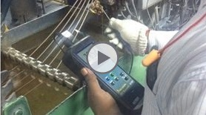
- During polymerization, if calcium chloride is added, the molecular weight will increase.
- The impact resistance can be improved with the inclusion of block copolymers in initial reaction
- Sulfonic acid esters along with a nucleating agent would improve the crystallization rate
- With the addition of an alkali metal or alkali earth metal dithionate in the mixture, they would increase the heat stability and lower the crystallization temperature
Popular Applications of PPS
The excellent properties of PPS with its ease of production and moderate cost makes it one of the most suitable choices for various applications where cost and high performance are essential.
Automotive Applications/ Automobile Parts
Polyphenylene Sulfide applications in automotive market have seen strong growth mainly due to its ability to replace metal, thermosets and other types of plastic, in more demanding applications. It is an ideal choice for automotive parts exposed to:
- High temperatures,
- Automotive fluids, or
- Mechanical stress
PPS is a lighter weight alternative to metals, resistant to corrosion by salts and all automotive fluids. The ability to mold complex parts to tight tolerances and insert molding capability accommodate multiple component integration.
Under-the-hood is the largest application area for PPS followed by electrical parts. PPS applications in automotive include fuel injection systems, coolant systams, water pump impellers, thermostat holder, electric brakes, switches, bulb housing and so on.
It is rarely used for the manufacture of interior or exterior auto parts.
» Select Suitable PPS Grade for Your Automotive Application
Electronic and Electrical Applications
Owing to its high temperature resistance, high toughness, good dimensional stability and good rigidity, PPS becomes an ideal material of choice in E&E market.
- Offers excellent flow and low shrinkage for precision molding of connectors and sockets
- Provides superior stiffness and mechanical integrity for reliable assembly, and
- Is the most stable material choice for all soldering methods
- PPS compounds also have UL94 V-0 flammability ratings without the use of flame retardant additives. Special low flash grades have been developed to meet the needs of high precision molding applications.
In the electrical / electronic sector, Polyphenylene Sulfide is also used to manufacture a range of articles including bobbins and connectors, hard disk drives, electronic housings, sockets, switches and relays. The key trend influencing PPS growth in electrical / electronic applications is substitution of other lower temperature polymers.
Appliances
Thanks to its exceptional dimensional stability, low density, corrosion- and hydrolysis resistance, PPS can be used to manufacture heating and air conditioning components, fry pan handles, hair dryer grills, Steam iron valves, toaster and dryer switches, microwave oven turntables etc. in electric appliances.
Industrial Applications
PPS has been replacing metal alloys, thermosets, and many other thermoplastics in mechanical engineering applications. The thermal stability and broad chemical resistance of Polyphenylene Sulfide make it exceptionally well suited to service in very hostile chemical environments.

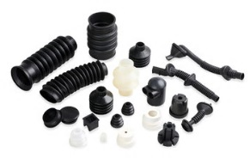
- It finds uses in many heavy industrial applications, including some outside the arena of reinforced injection molding compounds
- It is used in fiber extrusion as well as in non-stick and chemical resistant coatings
- It is well suited to manufacture mechanically and thermally highly stressed molded parts
- In machine construction and precision engineering, PPS is used for various components such as pumps, valves and piping
- It can also be found in oil field equipment such as lift and centrifugal pump components, oil patch drop balls, rod guides and scrapers
- In the heating, ventilation and air conditioning (HVAC) equipment sector, Polyphenylene Sulfide is used for compressors, mufflers/reservoirs, hot water circulation components, induced draft blower housing, motor relays and switches, power vent components and thermostat components
» Find Suitable PPS Grade for Your Engineering Application
Medical and Healthcare Applications
PPS compounds (typically glass reinforced grades) are used in medical application such as surgical instruments and device components & parts that require high dimensional stability, strength and heat resistance. PPS fibers are also used in medical fibers and membranes.
Processing Conditions for PPS
PPS resins (base polymer, glass-reinforced, and mineral/glass-reinforced systems) are typically used for injection molding, extrusion blow molding, and extrusion applications.
Polyphenylene Sulfide can be processed at temperatures in the range of 300 to 350°C. The processing of PPS can be hampered at times due to its high melting point.
If the PPS used is of the filled grade, the upper processing temperature should be used to avoid any kind of wear and tear of the barrel, screw and screw tip.
Pre-drying
Pre-drying at 150-160°C for 2-3 hrs or 120°C for 5 hours is recommended to enhance molded products appearance and prevent drooling.
For carbon fiber filled grades, pre-drying is particularly important, because moisture absorption is high due to the carbon fibers.

Injection Molding
- Because of its low viscosity, mold tightness has to be checked
- Cylinder temperature: 300-320°C
- Mold temperature: 120-160°C, to obtain good crystallization and minimize warping
- Injection pressure: 40-70Mpa
- Screw Speed : 40-100 rpm
» View All PPS Grades Suitable for Injection Molding
But in order to have higher productivity, a mold temperature of 50°C followed by post crystallization at 200°C is possible, but it is not recommended for applications requiring high dimensional stability.
Extrusion
Extrusion PPS grades are commonly available for fiber and monofilament production as well as tubing, rod and slab.
- Drying conditions: 121° for 3 hrs
- Mold Temperature: 300-310°C
- Melt Temperature: 290-325°C
Commercially Available PPS (Polyphenylene Sulfide ) Compounds
TORELINA™ A504X90 Toray
TORELINA™ A504X90 by Toray is a branched polyphenylene sulfide (PPS) grade reinforced with 40% glass fiber. It is suitable for processing by injection molding. Offers excellent heat resistance... view more
TORELINA™ A604 Toray
TORELINA™ A604 by Toray is a linear polyphenylene sulfide (PPS) grade reinforced with 40% glass fiber. It can be processed using injection molding. Offers high toughness, excellent heat resistance... view more
TORELINA™ A604WR Toray
TORELINA™ A604WR by Toray is a linear polyphenylene sulfide (PPS) grade reinforced with 40% glass fiber. TORELINA™ A604WR meets global regulatory standards for Water (NSF61) and Food Use (FDA) ... view more
TORELINA™ A504CX1B Toray
TORELINA™ A504CX1B by Toray is a polyphenylene sulfide (PPS) grade reinforced with 40% glass fiber. It imparts flame retardancy, excellent electrical properties, high mechanical strength, excellent... view more
TORELINA™ A604CX1B Toray
TORELINA™ A604CX1B by Toray is a polyphenylene sulfide (PPS) grade reinforced with 40% glass fiber. It offers flame retardancy, excellent electrical properties, excellent dimensional stability, high... view more
TORELINA™ A673MTB (Black) Toray
TORELINA™ A673MTB (Black) by Toray is a black colored, linear polyphenylene sulfide (PPS) grade reinforced with 30% glass fiber. It is suitable for processing by injection molding. Possesses high... view more

View All PPS Grades
<iframe src="//www.googletagmanager.com/ns.html?id=GTM-KTP5T2" height="0" width="0" style="display:none;visibility:hidden"></iframe>

